Afeef Bari

Assignment 4: API Testing using Postman

Creating a Collection and an environment and added a variable in the collection
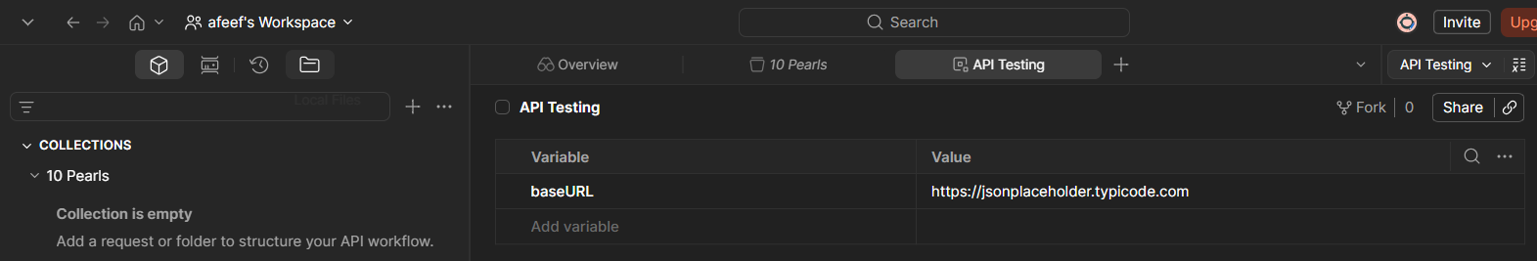
Sent the request using GET and received a response in JSON
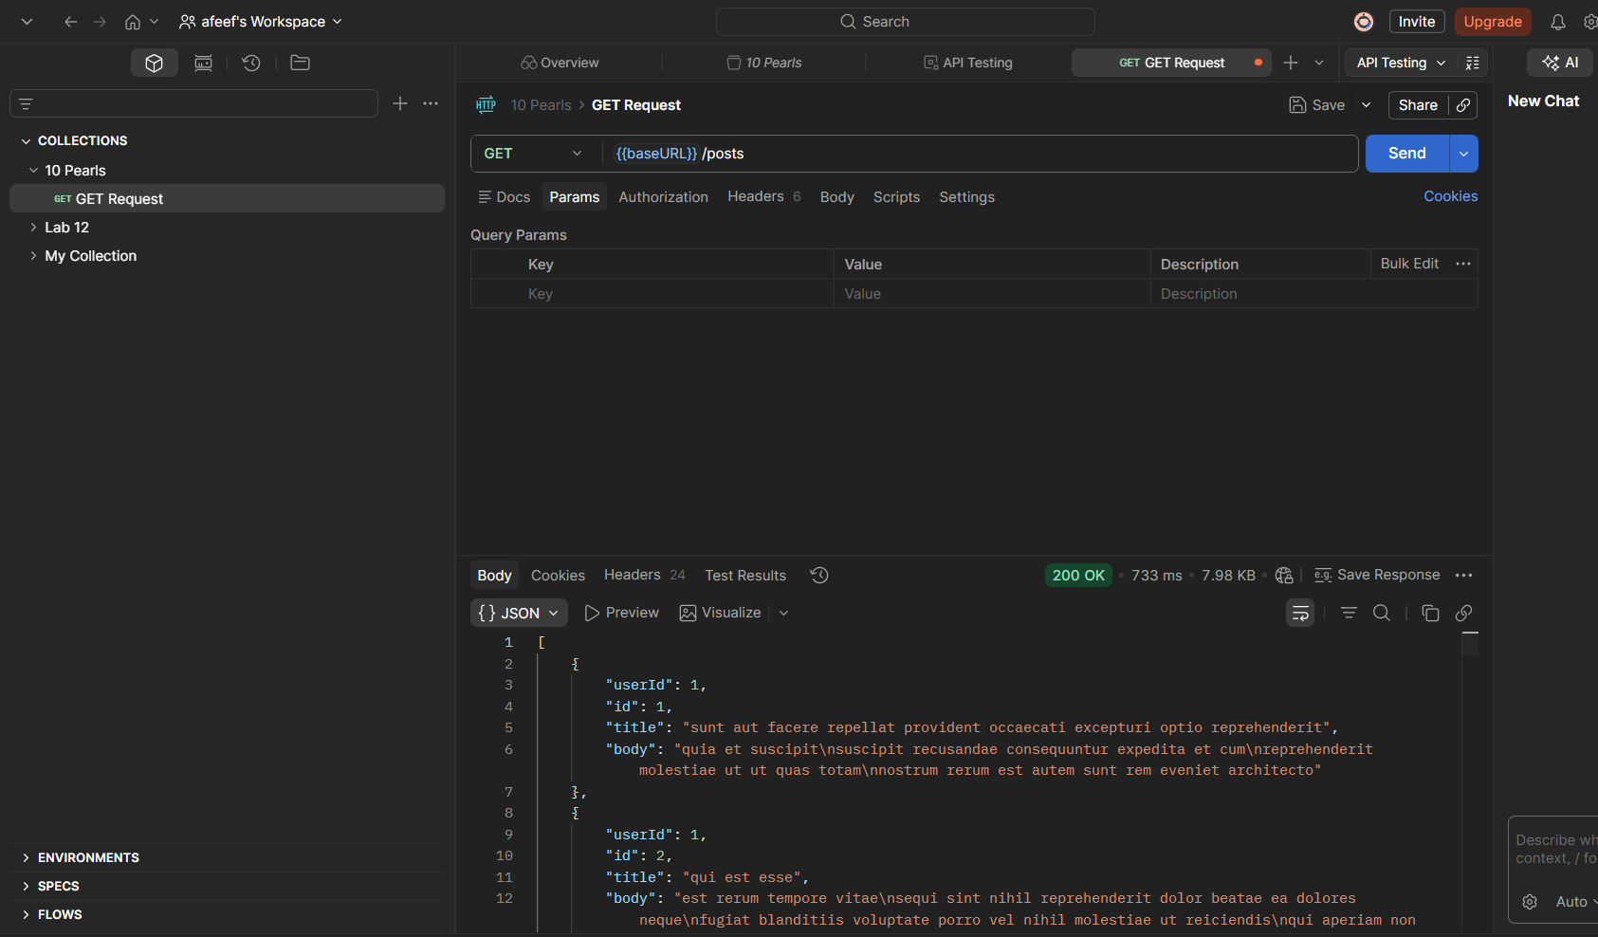

Using POST Request
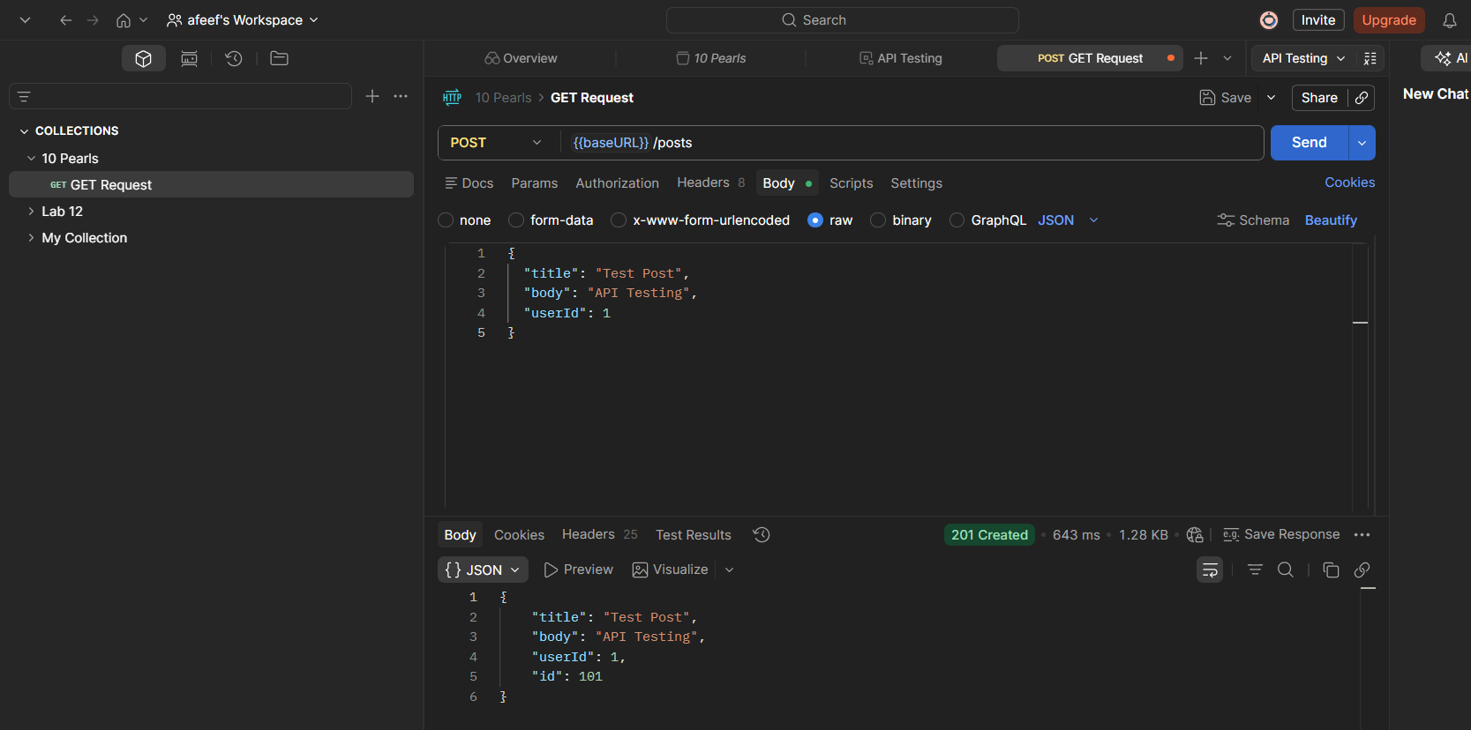
Created a test to check the POST Request
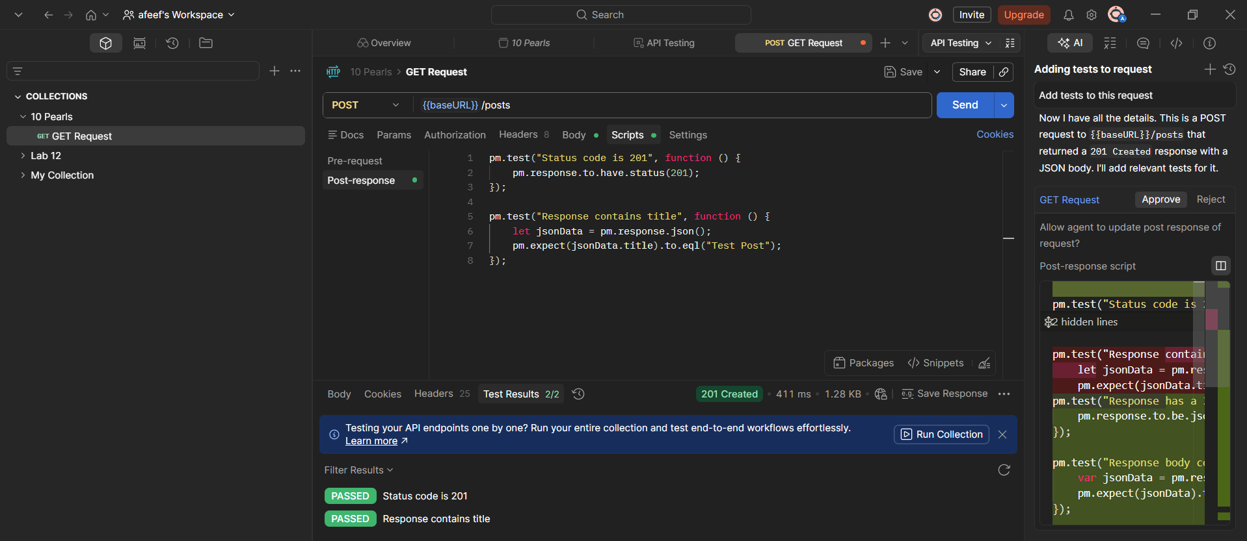

Created a Failed test to check
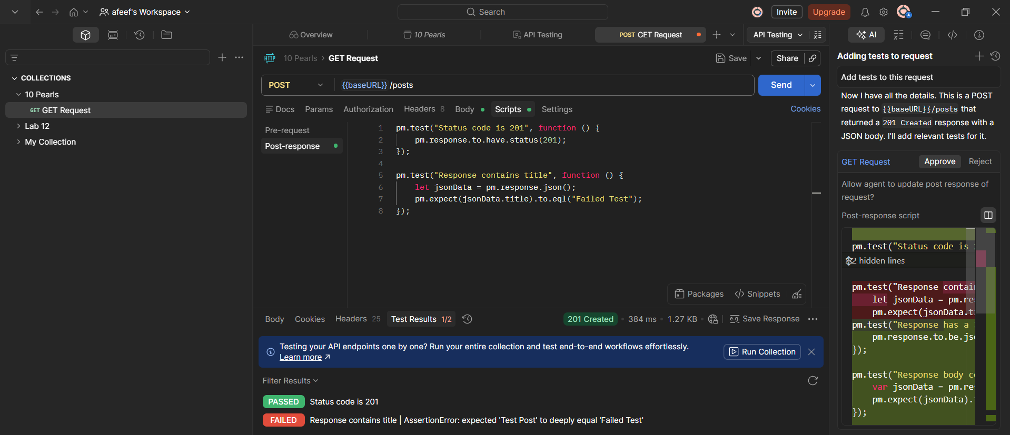
Ran multiple Tests
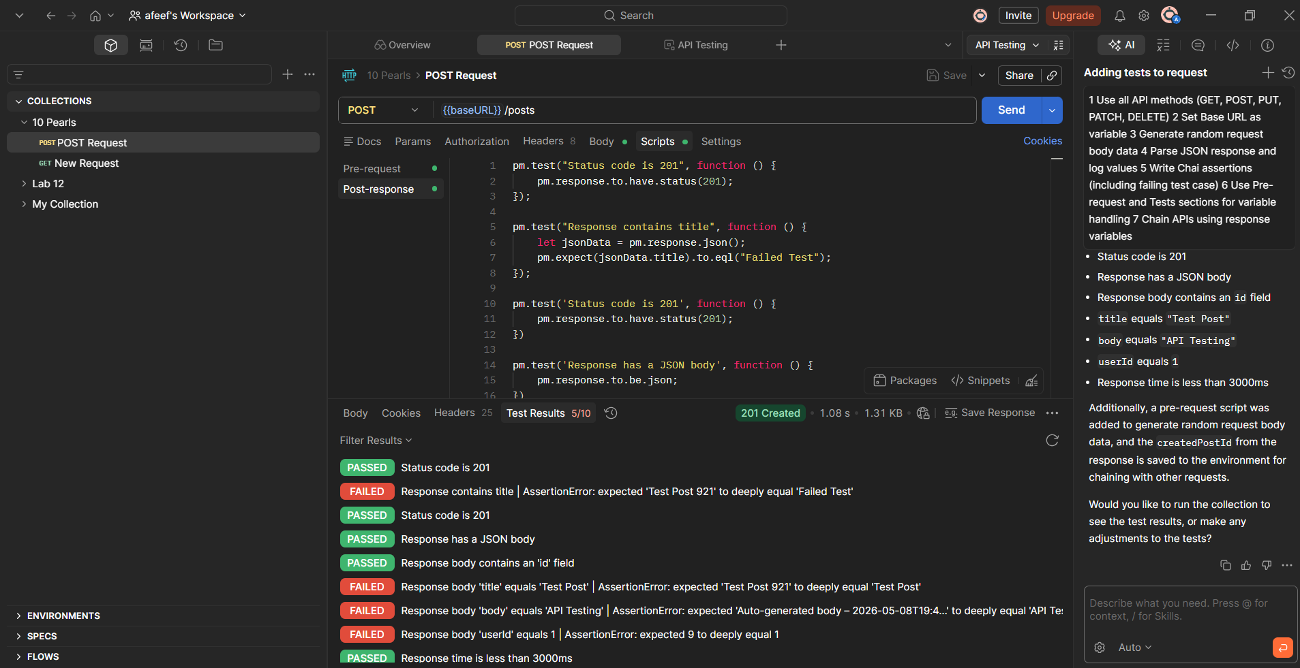

PUT Request
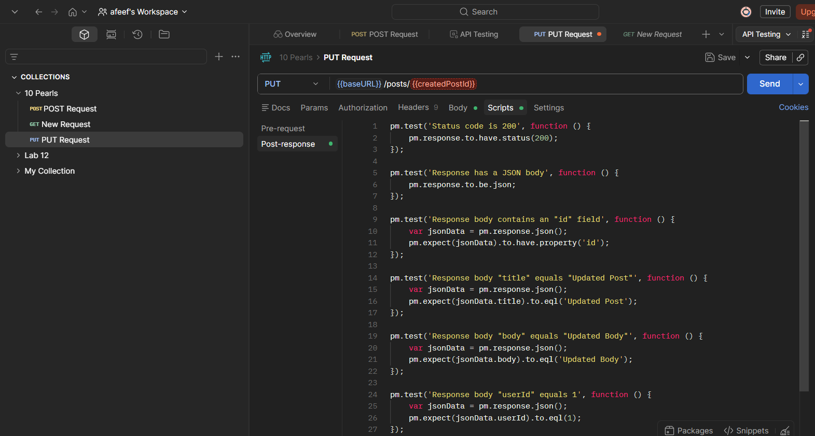
PATCH Request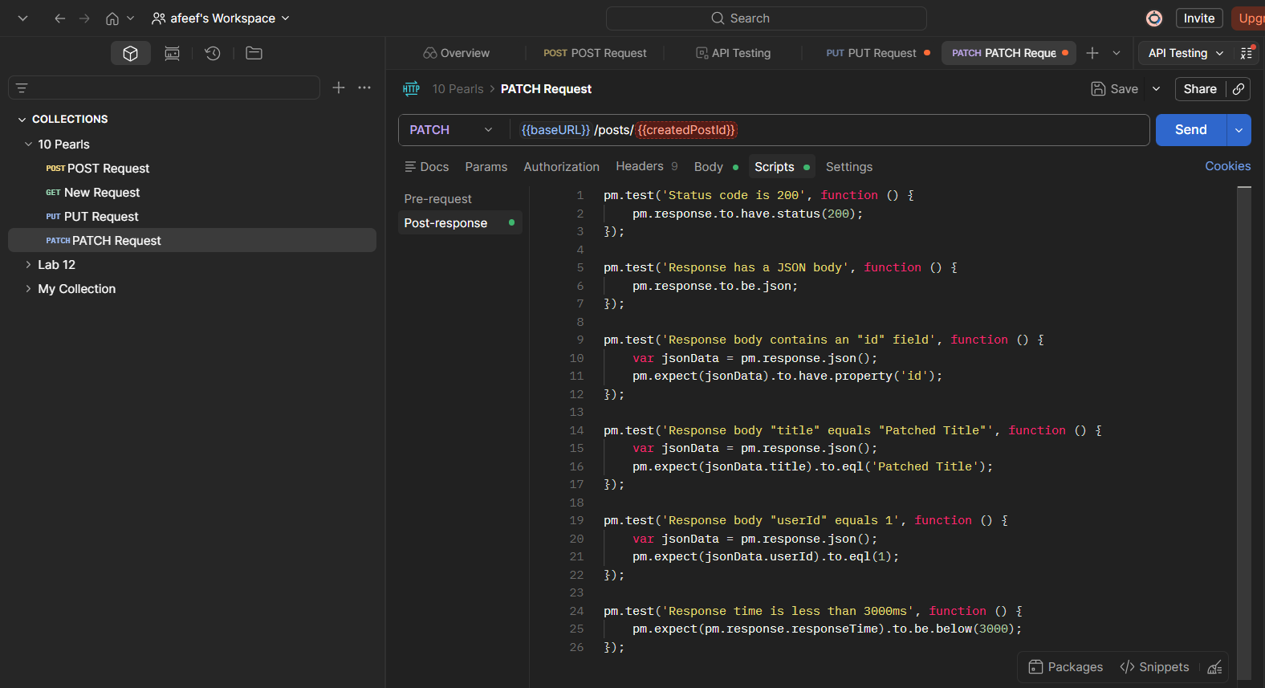

DELETE Request
